DIVIDENDS

Normally, when anybody asked about dividend question sounds like - "How many dividends I need to pay in current period?". But this is an incorrect question, because it is important not only - how much to pay, but also - how to pay.

*In previous versions of GMC-simulator typical scheme of dividend payments was 2% + 8% (1% + 4% or 3% + 12%, distribution of payments 1 to 4). Pay 2% dividends in 3 period and 8% in 5 period (in old version of GMC-simulator dividends were payed through period). Then you need to calculate amount of dividends with preserving required liquidity of the company and split payment in 2 periods.*

Schedule of dividends payment in new version of GMC-simulator playes much greater role than in previous, and therefore strategy of dividends payment is reduced to 2 key areas:

1．Amount of dividends payment.

2．Schedule of dividends payment.

**Amount of dividends payment**

Maximum possible amount of dividends depends on several limits:

1．In 5 period it is necessary to maintain requied level of liquidity, because it is one of the goodwill factors. So, before the game you should prognoze how much profit you can get in each period and add this to cash balance. Requied level of liquidity in 5 period must be at least 10% of net assets of the company, the rest can be paid to shareholders as dividends.

2．In previous paragraph you may decide that you need to pay the maximum amount of dividends based on 10% liquidity, but it is important to consider another limit. [Remember how to calculate investment perfomance](https://gmcworld.org/blog/investment-perfomance).

IP = MV + DIV + SIR, where MV = GW * NA

Payment of dividends increases IP through the term DIV in arithmetic progression. Also, due to the payment of dividends changes term MV. On the one hand it increases goodwill (GW), but on the ther hand decreases net assets (NA). Finding right balance between all components will be the key to optimal amount for devidends payment.

Visually, this dependence can be seen on the chart. Horizontal - amount of dividends paid during the game. Vertical (left) - absolute value of goodwill factors. Vertical (right) - absolute value of investment perfomance. Blue - value of goodwill factor (dividends). Green - ratio between liquidity and net assets. Red - absolute value of the investment perfomance.

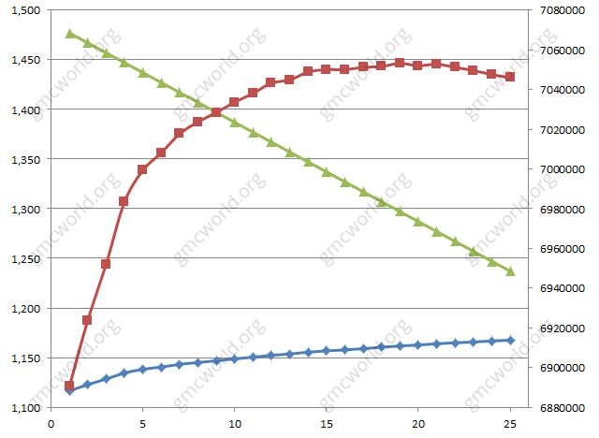

Chart shows that the optimum dividends payment will be in the area 18% - 20%, which must be properly distributed for 5 periods.

**Schedule of payment of dividends**

Important innovation in new version of GMC-simulator was ability to pay dividends to shareholders every period, while in old version payment could be done only through the period. Finding optimal strategy for dividends payment thought testing is extremely difficult, because requires very large number of test groups with identical decisions. Searching relevant pairs for analysis in management reports database does not give desired result, but ... good people helped, so read carefully.

Tests were made with different payment schedules with identical decisions. Test results show following rules of dividends payment:

1．Payment schedule must be continuous. If you payed dividends in previous period, then be sure to pay dividends in current period. Therefore, if you are unsure that you have enough money for the following periods, it is better not to pay anything.  
0% - 1% - 2% - 3% - 4% - Correct  
1% - 0% - 2% - 3% - 4% - Incorrect

2．Payment of dividends should be started as early as possible. Ideally, payment has to be payed in 1 period, because each next period annual interest rate of the bank is added to the amount of payment, which takes into account of investment perfomance.

3．Dividends payment in current period should be 50% more than payment in previous period, ie each subsequent payment should be increased by 1.5 times (rounded to the nearest whole number, in extreme cases payment may be equal to the previous one). Knowing total amount of dividends that should be payed during the game, you need to generate a shedule based on this coefficient.

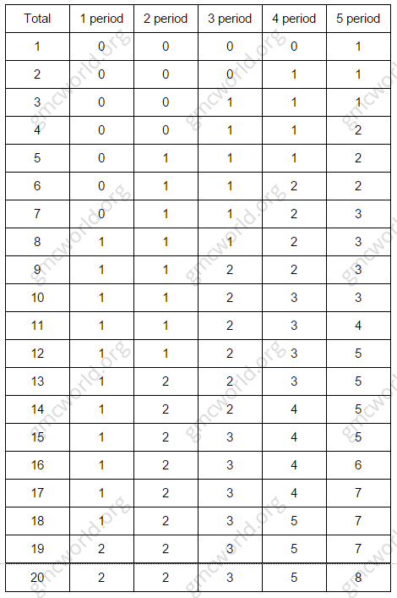

股息

通常情况下，当有人问股息问题听起来像“当前需要支付多少股息”？ 但这是一个不正确的问题，因为重要的不仅是 - 支付多少，而且 - 如何支付。

*在以前版本的GMC模拟器中，典型的股息支付方案为2％+ 8％（1％+ 4％或3％+ 12％，支付分配1到4）。 在3期内支付2％的股息，5个期间的8％（旧版GMC模拟股息按期支付）。 那么你需要计算公司的股利数量，保留公司所需的流动性，并在两个时期内分配付款。*

新版GMC模拟器板块的股利支付计划比以往更大的作用，因此股息支付策略减少到2个关键领域：

1．股息支付的数量。

2．股息支付的计划。

**股息支付的数量**

最高可能的股息数量取决于几个限制：

1．在5个时期内，有必要保持所需的流动性水平，因为它是友好的因素之一。所以，在游戏之前，你应该预测每个时期可以获得多少利润，并将其加到现金余额中。5个期间的流动性要求必须至少为公司净资产的10％，其余可以以股息方式支付给股东。

2．在上一段中，您可以决定您需要根据10％的流动性支付最高数额的股息，但重要的是考虑另一个限制。 记住如何计算投资绩效。

IP = MV + DIV + SIR，其中 MV = GW * NA

股息支付通过术语DIV在算术进程中增加IP。 另外，由于支付股息变动期限MV。 一方面增加商誉（GW），但另一方面减少净资产（NA）。 在所有组成部分之间找到正确的平衡将是优先付款的关键。

在视觉上，这种依赖可以在图表上看到。 水平 - 游戏期间支付的股息数额。 垂直（左） - 商誉因素的绝对值。 垂直（右） - 投资绩效的绝对值。 蓝色 - 商誉因子（股息）的价值。 绿色 - 流动性与净资产的比率。 红 - 投资性能的绝对价值。



图表显示，最佳股息支付将在18％ - 20％的区域，必须适当分配5个时期。

**股息支付的计划**

新版GMC模拟器的重要创新是能够在每个时期向股东支付股利，而旧版本的付款只能在此期间完成。寻找股利支付思想测试的最佳策略是非常困难的，因为需要非常大量的具有相同决策的测试组。在管理报告数据库中搜索相关对分析不会产生期望的结果，但是...好的人帮助，所以仔细阅读。

以不同的付款时间表做出相同决定的测试。 测试结果显示以下股息支付规则：

1．付款时间表必须是连续的。 如果您在前期支付股息，那么当然要在当期支付股息。 因此，如果您不确定您在以下期间有足够的钱，最好不要支付任何费用。

0% - 1% - 2% - 3% - 4% - 正确

1% - 0% - 2% - 3% - 4% - 不正确

2．股息支付应尽早开始。 理想情况下，付款必须在1个时期支付，因为下一年度的银行年利率被加入到支付金额中，这反映了投资绩效。

3．当期股利支付比上期付款多50％，即每次后续付款增加1.5倍（四舍五入到最接近的整数，极端情况下付款可能相当于前一个）。 知道在游戏中应该支付的股息总额，您需要根据这个系数生成一个计划。

